|  |
| --- |
| Data Report |
| F:\Springboard Google Drive\Springboard-Brian\Springboard Curriculum\Unit 6 - Guided Capstone\Ski.jpg |

|  |  |
| --- | --- |
| 06-Aug-2020 | Big Mountain Resort |

Ski lift cost recovery recommendations.

Data Report

Big Mountain Resort

# EXECUTIVE Summary

## To cover the additional operating costs of the new lift and to maintain a profit margin of at least 9.2% the ticket prices should be raised from $81 to $86-generating $1.75 mil in additional revenue. This will move Big Mountain Resort from the 84th percentile to the 87th percentile in price as compared to the other resorts in the marketplace. The additional $1.75 mil in revenue will cover the additional $1.54 mil in operating costs due to the new ski lift and the overall profit margin would increase to 9.3%

# Data & MODELING

Several linear regression models were used against a dataset of 300+ comparable resorts and the best model was chosen based on explained variance and mean absolute error. A summary table of the models used in the analysis is given below.

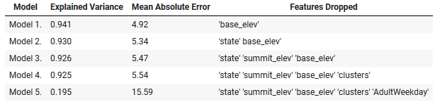

# Model 1

Model 1 was the best and it was used to predict the fair price of a weekend ticket for Big Mountain Resort based on all the available features. As can be seen below the model projected a price of $85.34, however, if you adjust the features to include an additional fastQuads lift the price prediction increases to $85.87.

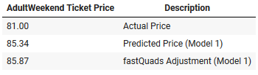

# ElevaTION Ranking

Big Mountain Resort (magenta data point) is in the middle of the pack when it comes to elevation ranking.

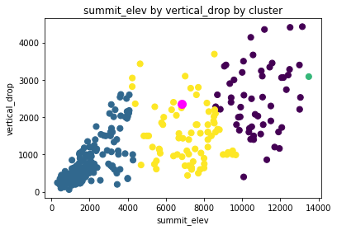

# PRICe Ranking

**Big Mountain Resort** (magenta data point) **is in the** 84th percentile in price ranking and will move up to the 87th percentile after the price is increased to $86. The resorts range in price from $17 to $179. The average price is approximately $64.

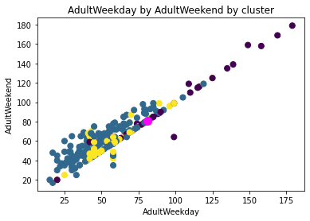

# Night Skiing Ranking

Big Mountain Resort (magenta data point) is classified as an outlier in this category and it could very well explain why the ticket prices at the resort command an above-average price.

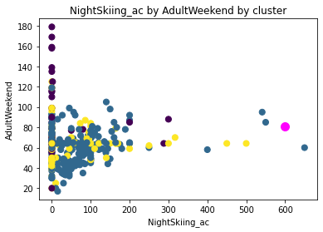

# Conclusions

Assuming Big Mountain Resort continues to attract 350,000 visitors per year at a ticket price of $81 the annual revenues would be $28.35 mil. With a historical profit margin of 9.2%, this would imply total expenses would be approximately $25.74 mil annually.

The additional operating expenses due to the new ski lift are $1.54 mil per year. Ticket prices only need to be raised $4.4 to cover the cost of these additional expenses, however, to maintain the 9.2% historic profitability more revenue needs to be generated.

The pricing model in this report suggests a fair price of $86 for a Big Mountain Resort ticket. At this price point, the resort will generate $1.75 mil in additional yearly revenue and have a 9.3% profit margin. The price ranking percentile will move up by 3% and still fall well with the range of competing resorts. Big Mountain Resort does have a very high night skiing ranking that can help the marketing department justify its above-average pricing.

# SUpporting Calculations













